|  |  |
| --- | --- |
| ANDBON AD-100S moisture-proof cabinet  Tủ chống ẩm ANDBON AD-100S  tu-chong-am-andbon-ad-100c tu-chong-am-andbon-ad-100c-1 tu-chong-am-andbon-ad-100c-2 | **Featured information:**  There are 5 pull-out compartments  Power capacity: 5W/H  Capacity: 100L  Voltage used: 110-220V  Price: $ 175  **Specifications:**  Product dimensions (inside) 378x360x940mm  Product dimensions (external) 380x390x1015mm  Dimensions of the whole box are 440x450x1070mm  Product weight 14kg  Made in Taiwan |

**Overview:**

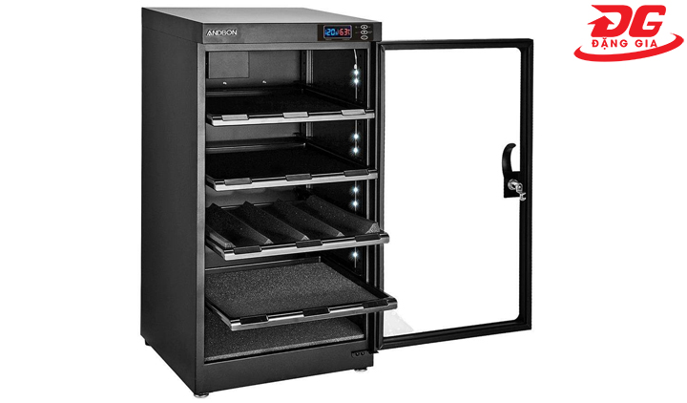

ANDBON AD-100S anti-humidity cabinet is made from thick, durable steel and operates using semiconductor technology to create a dehumidifying environment. Then the moist air inside will condense and be sucked out by the dehumidifier. Compact design, delicate colors, ANDBON AD-100C can be placed anywhere in your home.